LAB 1

Develop a Java program that prints all real solutions to the quadratic equation ax2 +bx+ c = 0. Read in a, b, c and use the quadratic formula. If the discriminate b2-4ac is negative, display a message stating that there are no real solutions

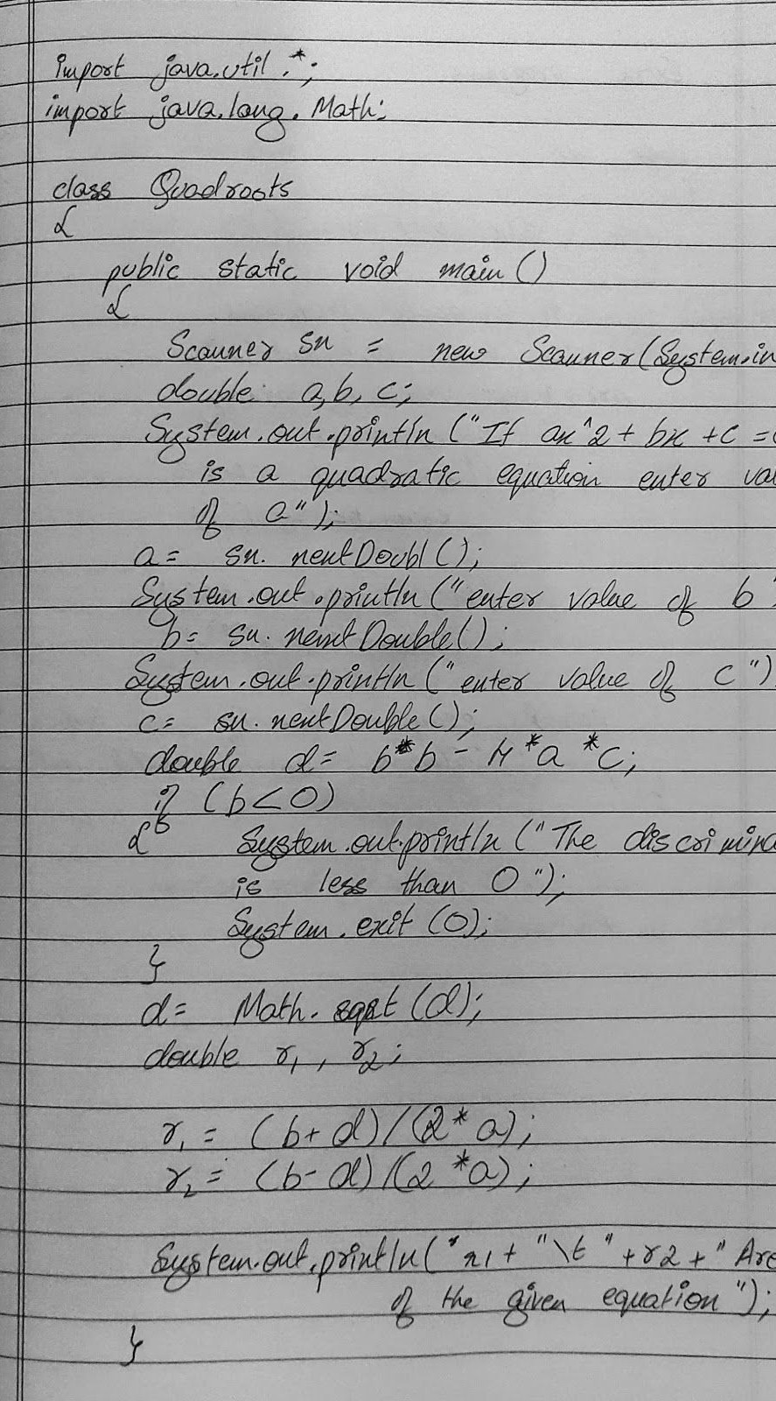



$ java quadroots

7

Then enter the va1ue of

8x’2 e bX + C = e is a quadratic equation

a

enter the value of b S

nter value of c

1

he Discriminant is negative! Equation

has imiginary

roots!!

|  |  |  |  |
| --- | --- | --- | --- |
| If ax’Z + bx + | | e is | a quadrat1c equat1on |
| Then ent:er the value ’of a | | | |
| enter the value of b | | | |
| -6 |  | | |
| enter value of c | | | |
| 9 | | | |
| The roots of the equation .are 3.eand 3.e | | | |

LAB 2:-

Develop a Java program to create a class Student with members usn, name, an array

credits and an array marks. Include methods to accept and display details and a method to calculate SGPA of a student.

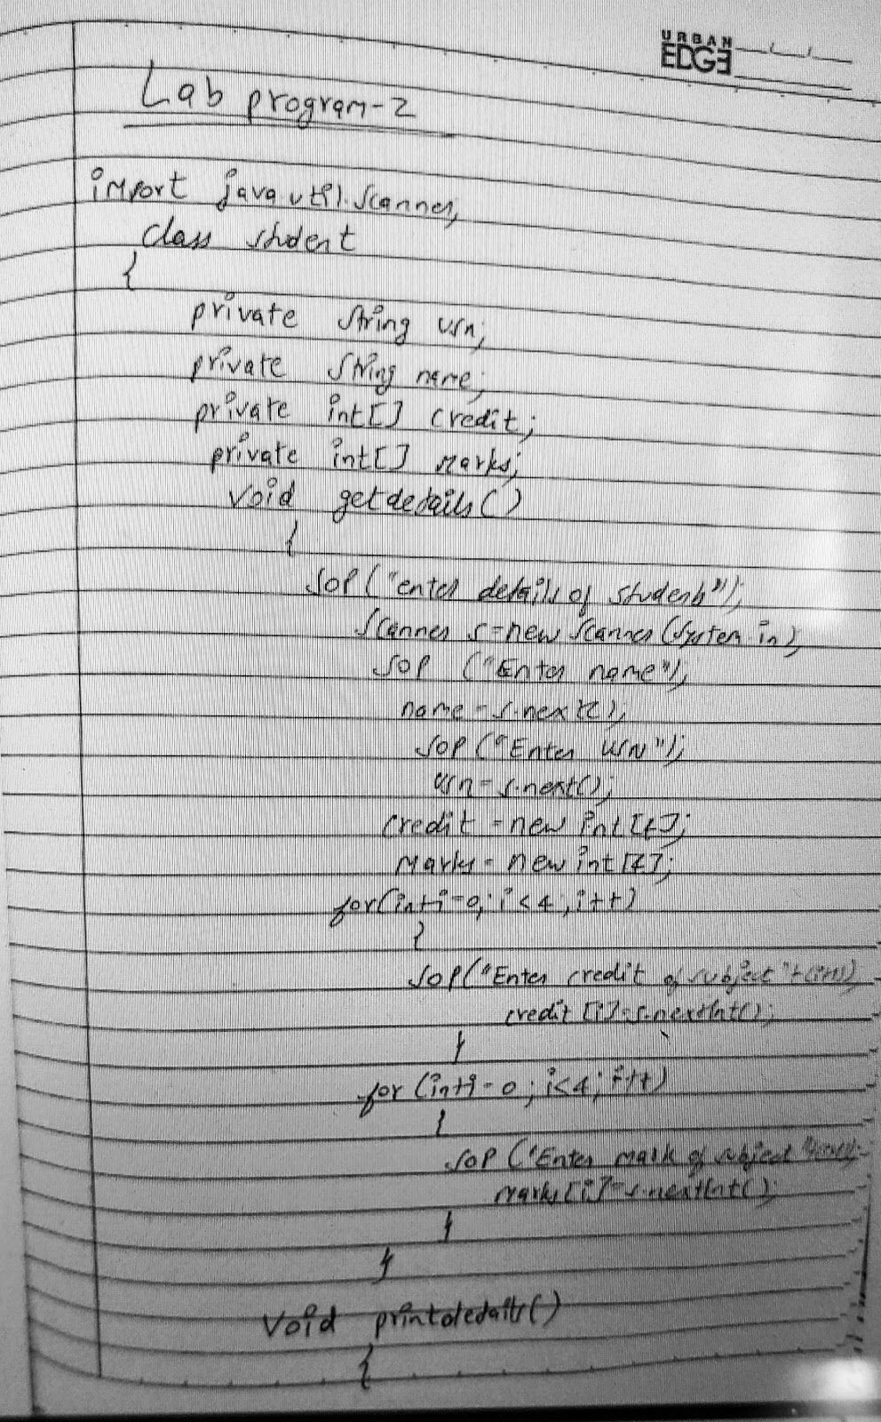

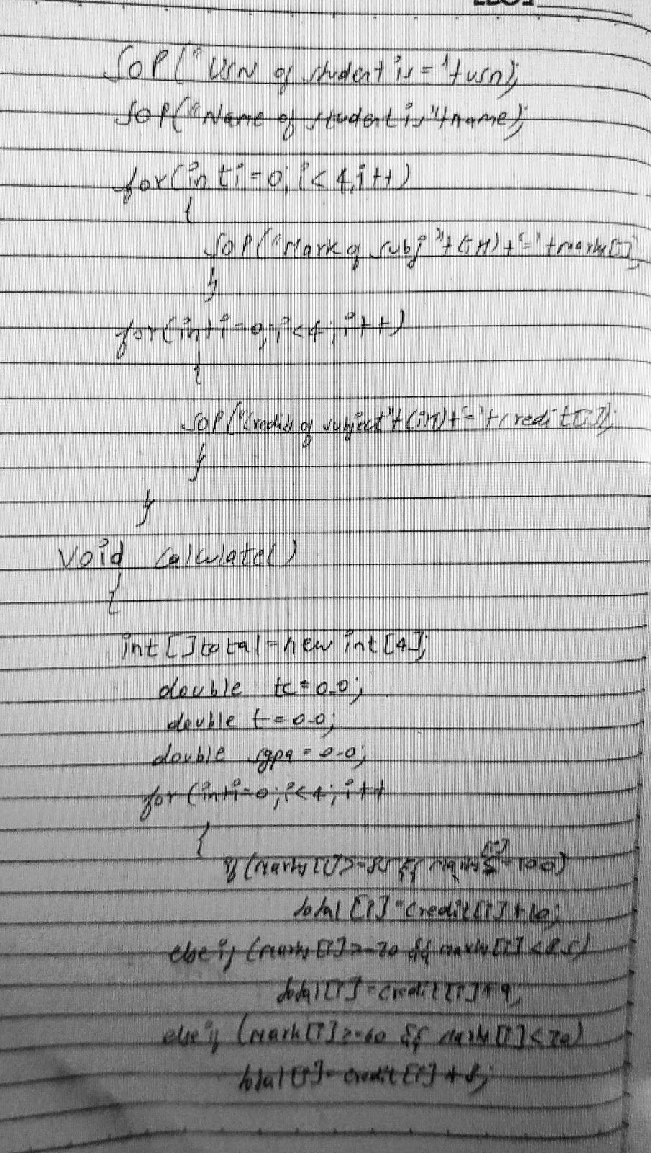

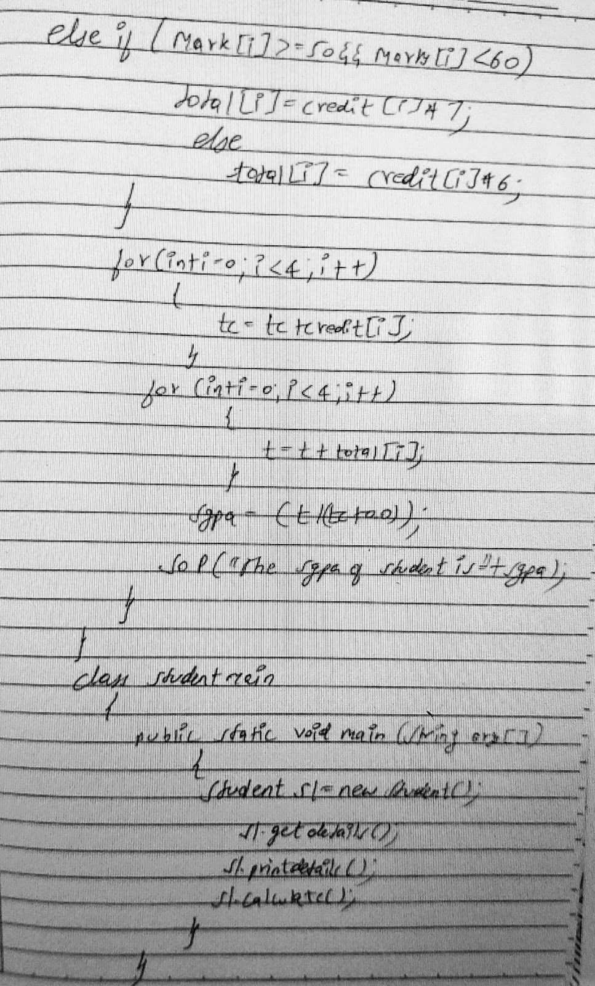



lEnter the naMe 3eevan

enter the lJSlJ

1Bh19CS884

Enter the marks 1n subjects

S6

Enter the Credits for respective subjef S

s s

USN: 1BN19CSe84

Naae: 3eevan

xarks: u 56 7i se 9e

Credits: 1 1 1 5 5

The S.G.P.A 1s: 7.615384615384615

LAB 3:-

Create a class Book which contains four members: name, author, price, num _pages. Include a constructor to set the values for the members. Include methods to set and get the details of the objects. Include a toString( ) method that could display the complete details of the book. Develop a Java program to create n book objects.

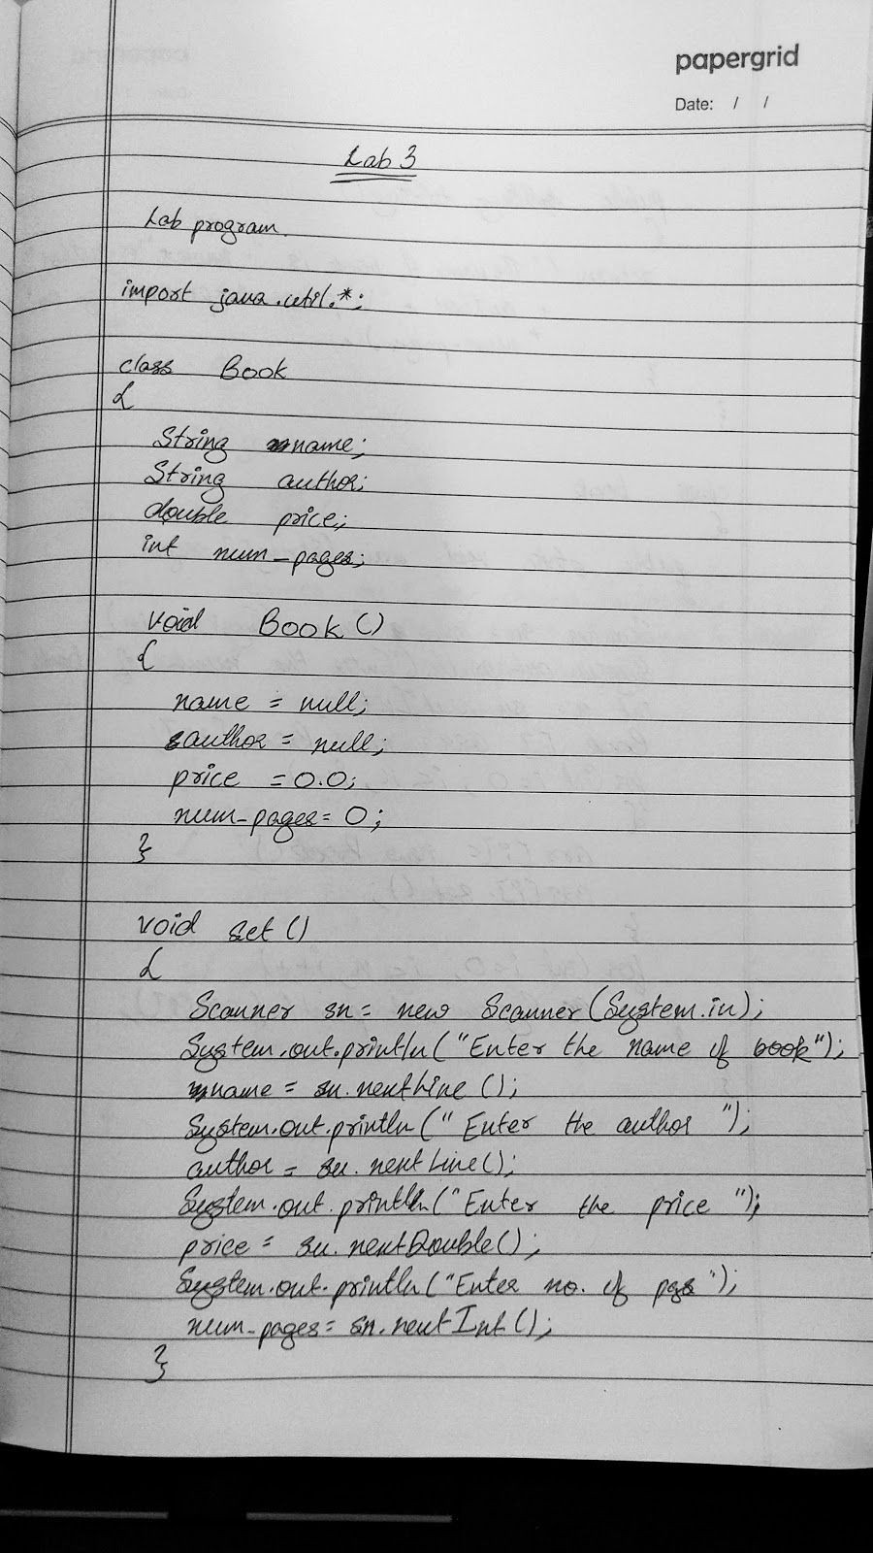

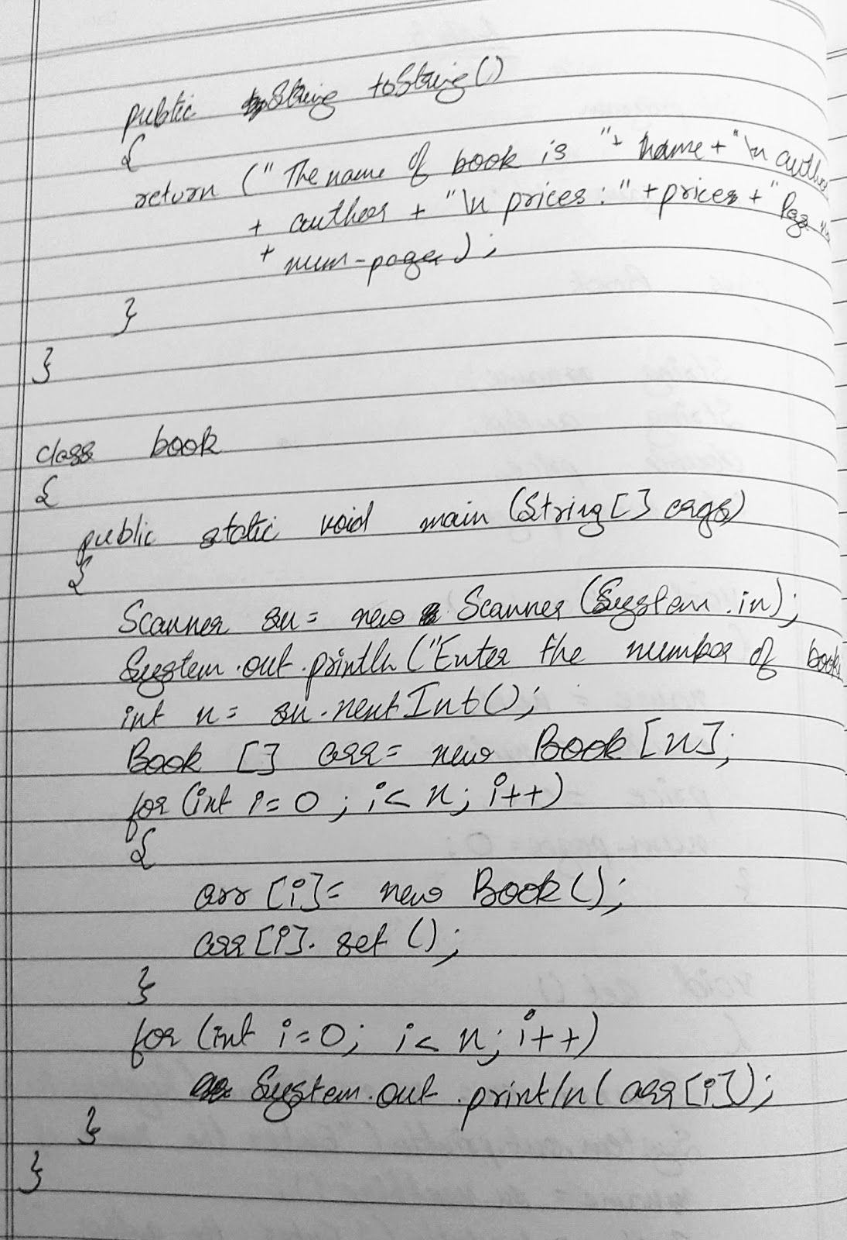

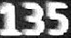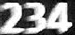

Enter deta11s of book 1

Enter book neme

donkeys

Enter book id

Enter nane

Pub11sher

]001

name

hook 1d

name

Ent«r Publisher na/ze

Enter number of pages

book

details of book 2

number of pages

the pr1ce

year of publication

RK

the price

year of publication

aut:hor

Enter

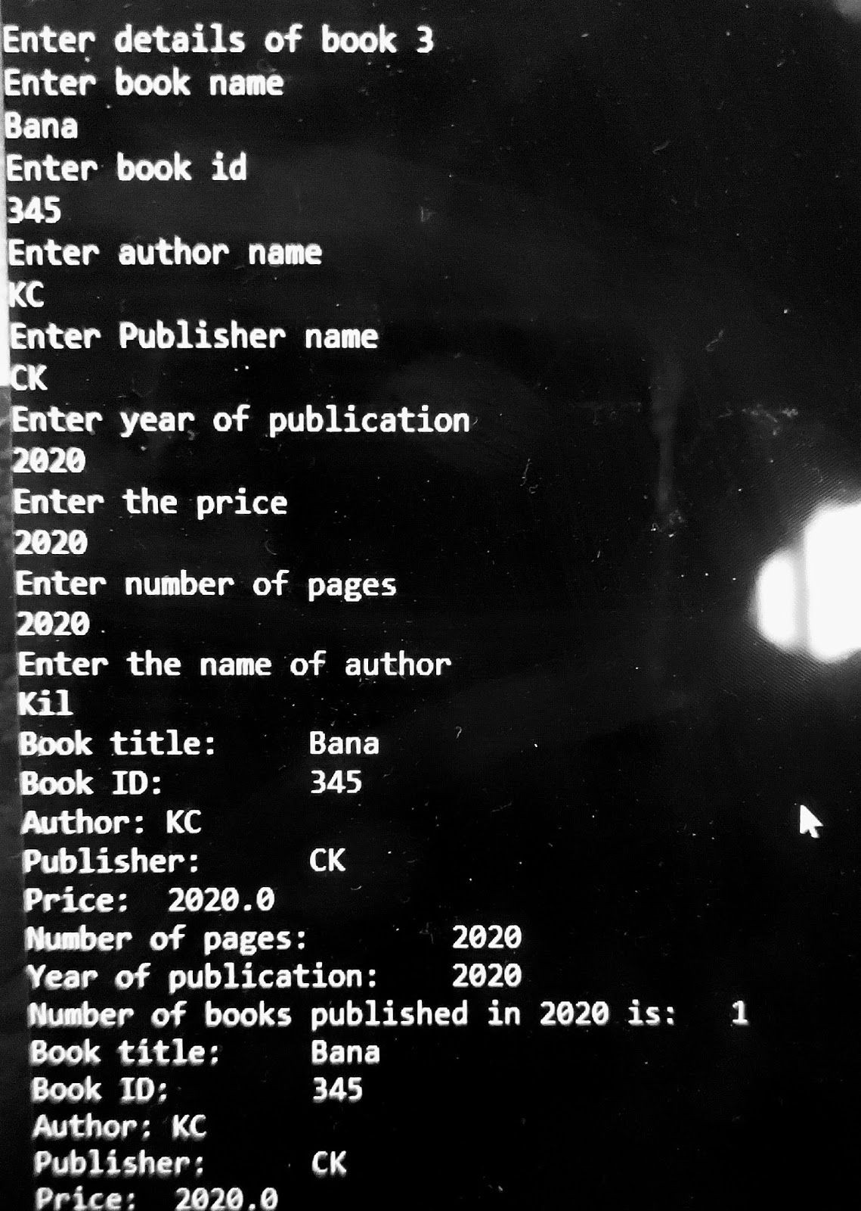

LAB 4

Develop a Java program to create an abstract class named Shape that contains two integers and an empty method named printArea( ). Provide three classes named Rectangle, Triangle and

Circle such that each one of the classes extends the class Shape. Each one of the classes contain only the method printArea( ) that prints the area of the given shape.

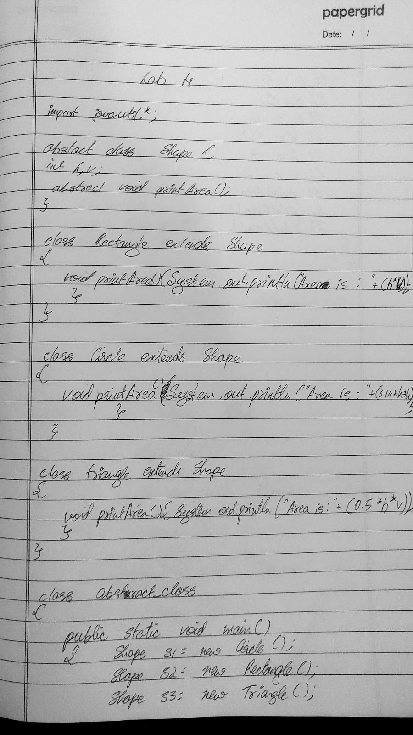

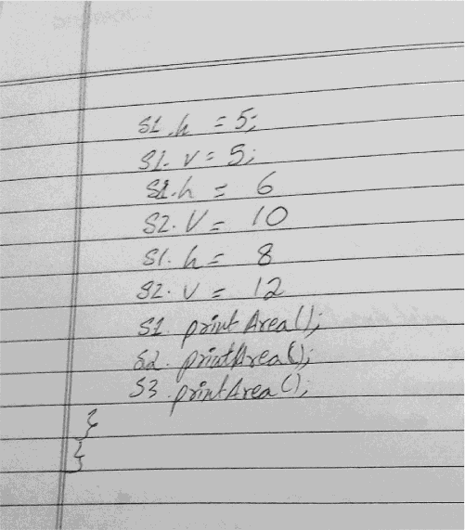



$ java abstract_c1ass

Area of Circle is: 78.5 Area of rectangle is: 60 Area of triangle is: 4g 0

LAB 5

Develop a Java program to create a class Bank that maintains two kinds of account for its customers, one called savings account and the other current account. The savings account provides compound interest and withdrawal facilities but no cheque book facility. The current account provides cheque book facility but no interest. Current account holders should also maintain a minimum balance and if the balance falls below this level, a service charge is imposed. Create a class Account that stores customer name, account number and type of account. From this derive the classes Curr-acct and Sav-acct to make them more specific to their requirements. Include the necessary methods in order to achieve the following tasks: • Accept deposit from customer and update the balance. • Display the balance. • Compute and

deposit interest • Permit withdrawal and update the balance • Check for the minimum balance,impose penalty if necessary and update the balance

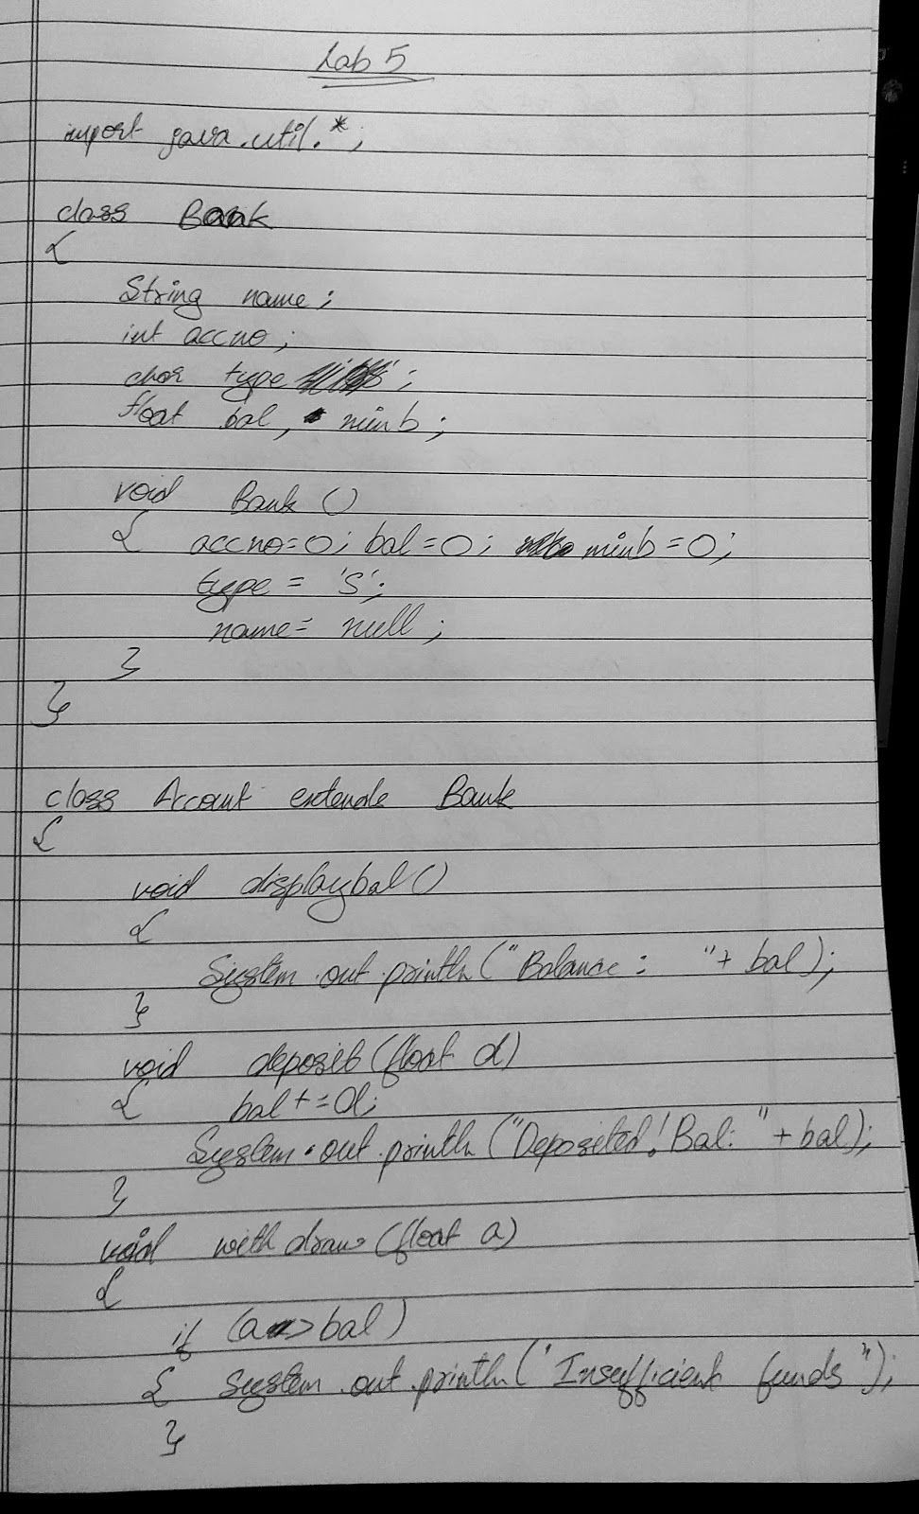

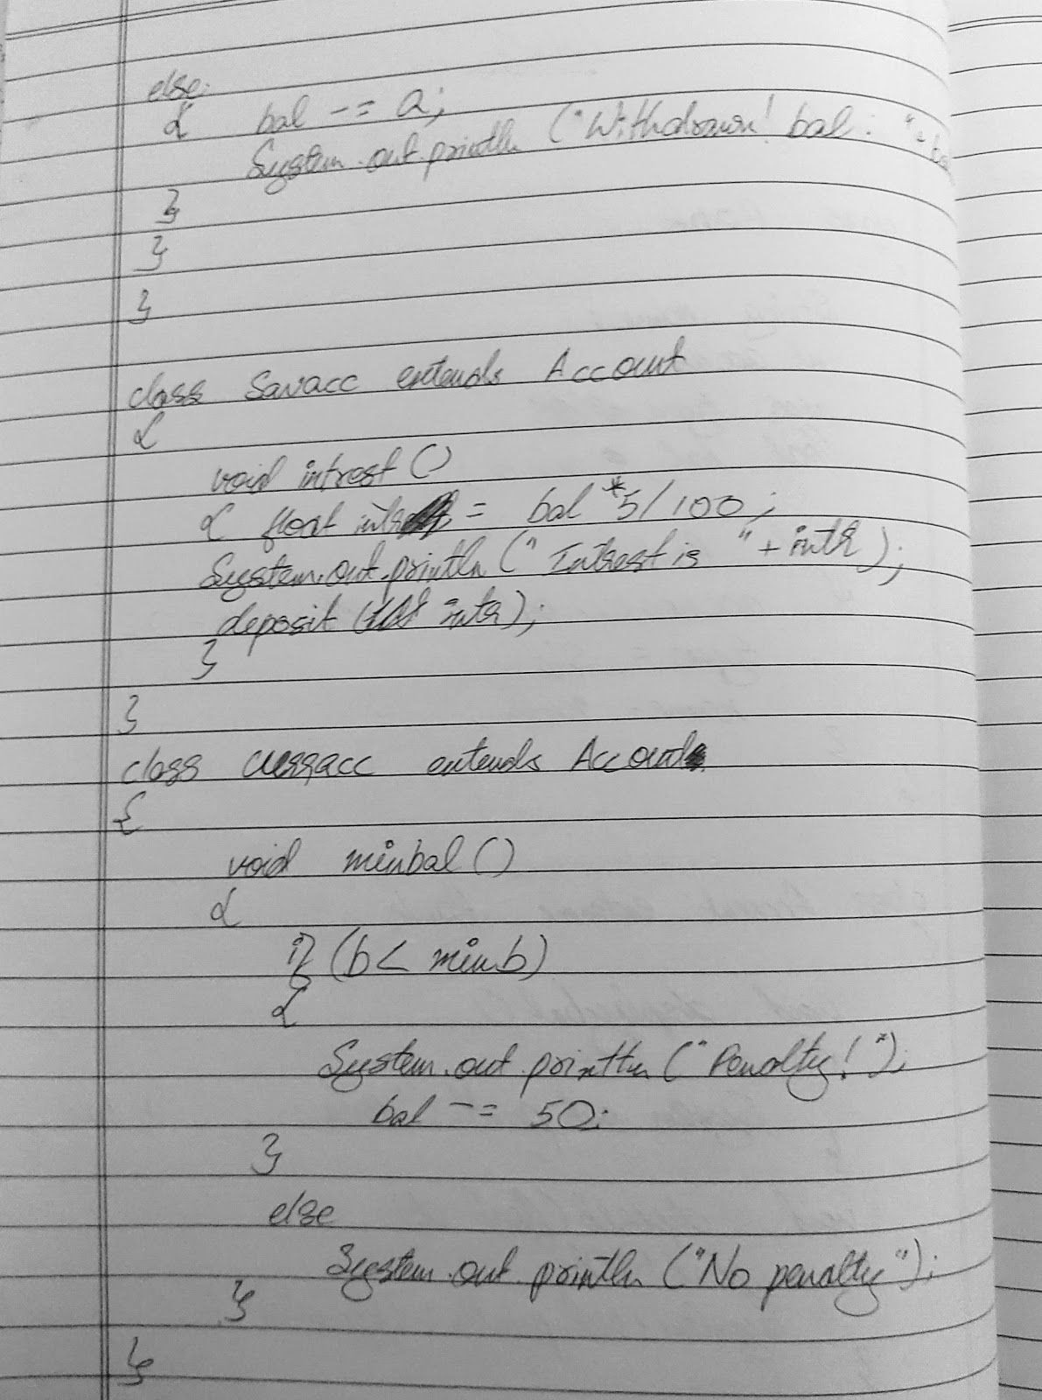

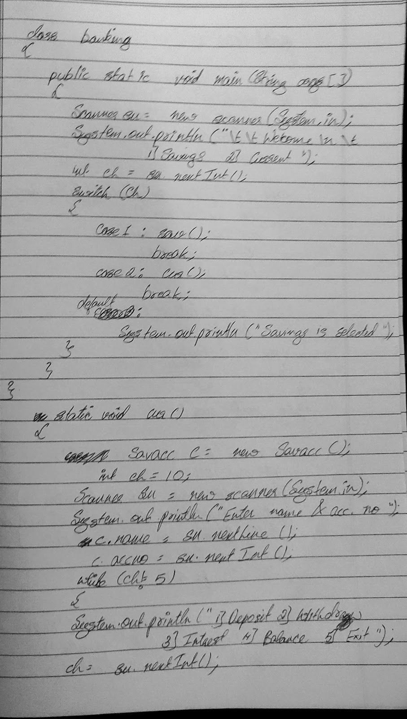

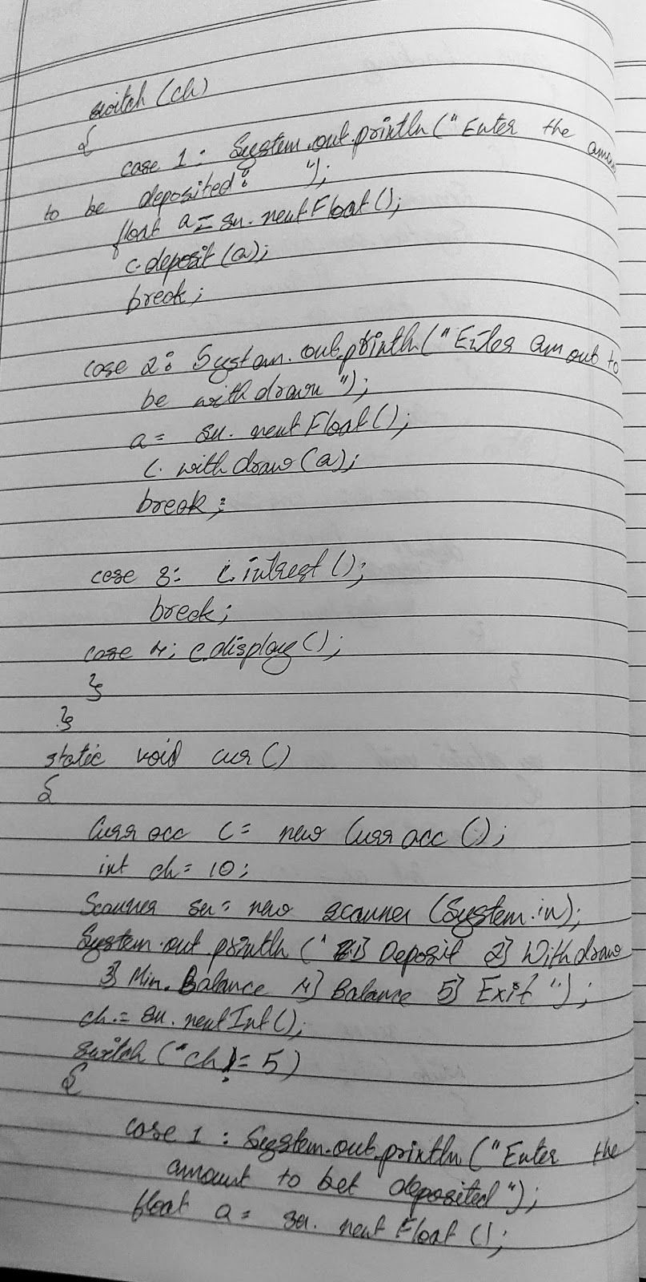

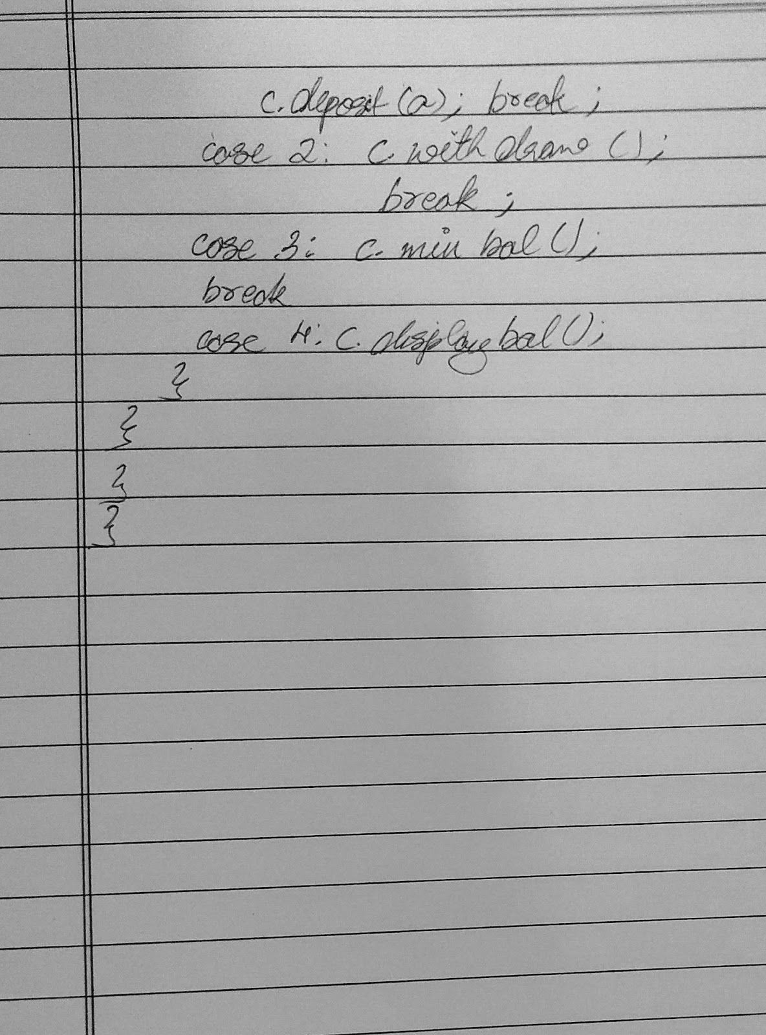

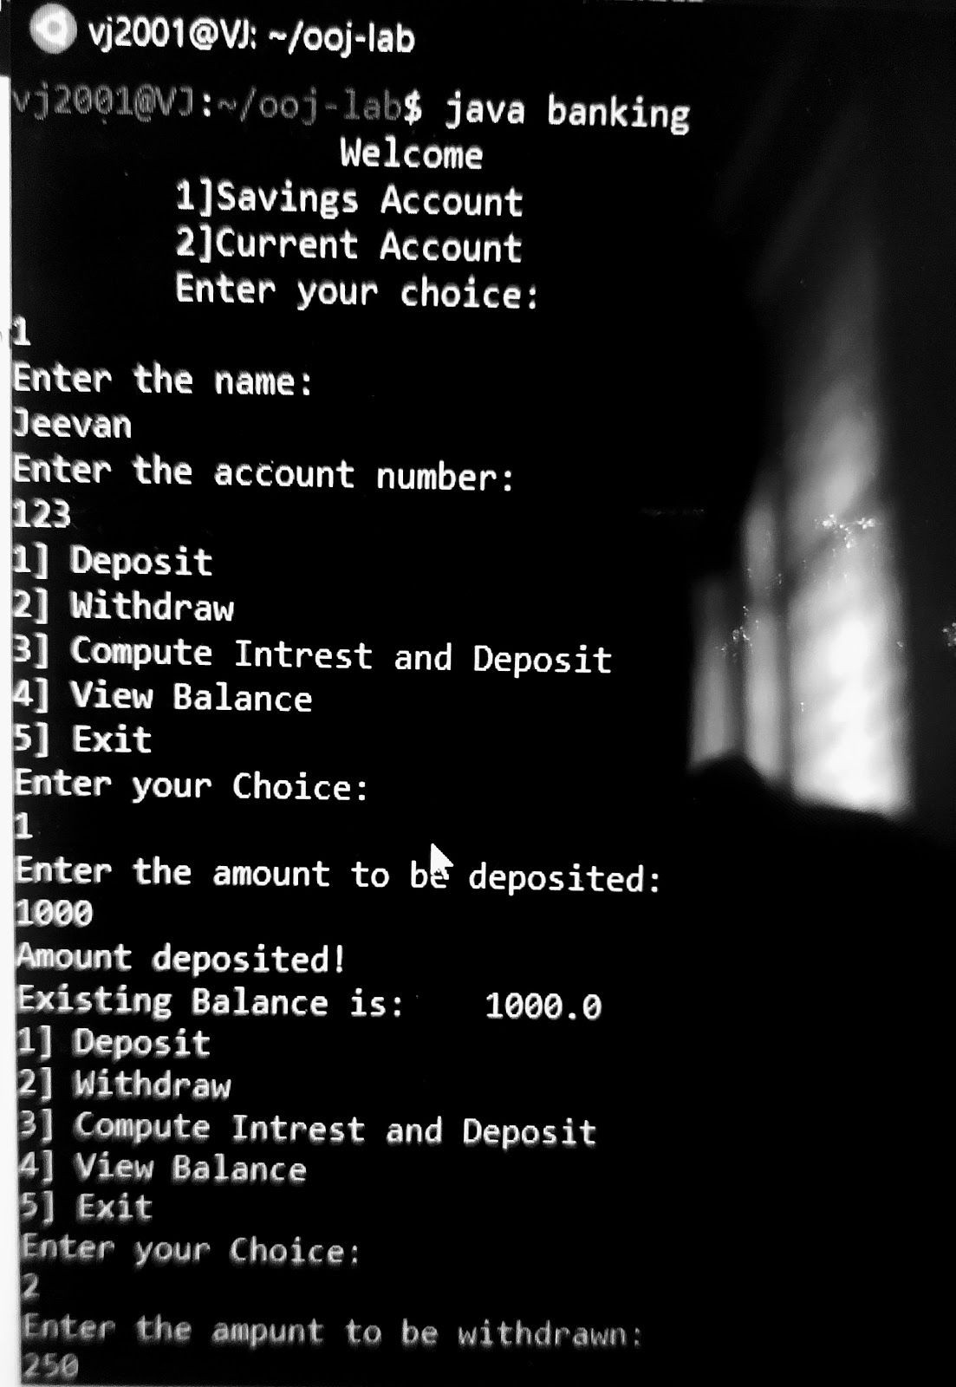

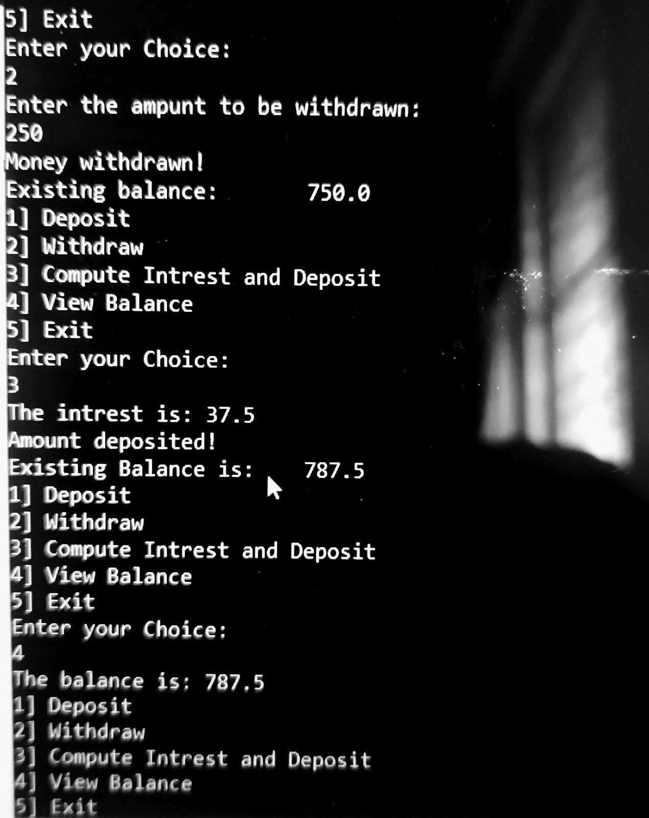

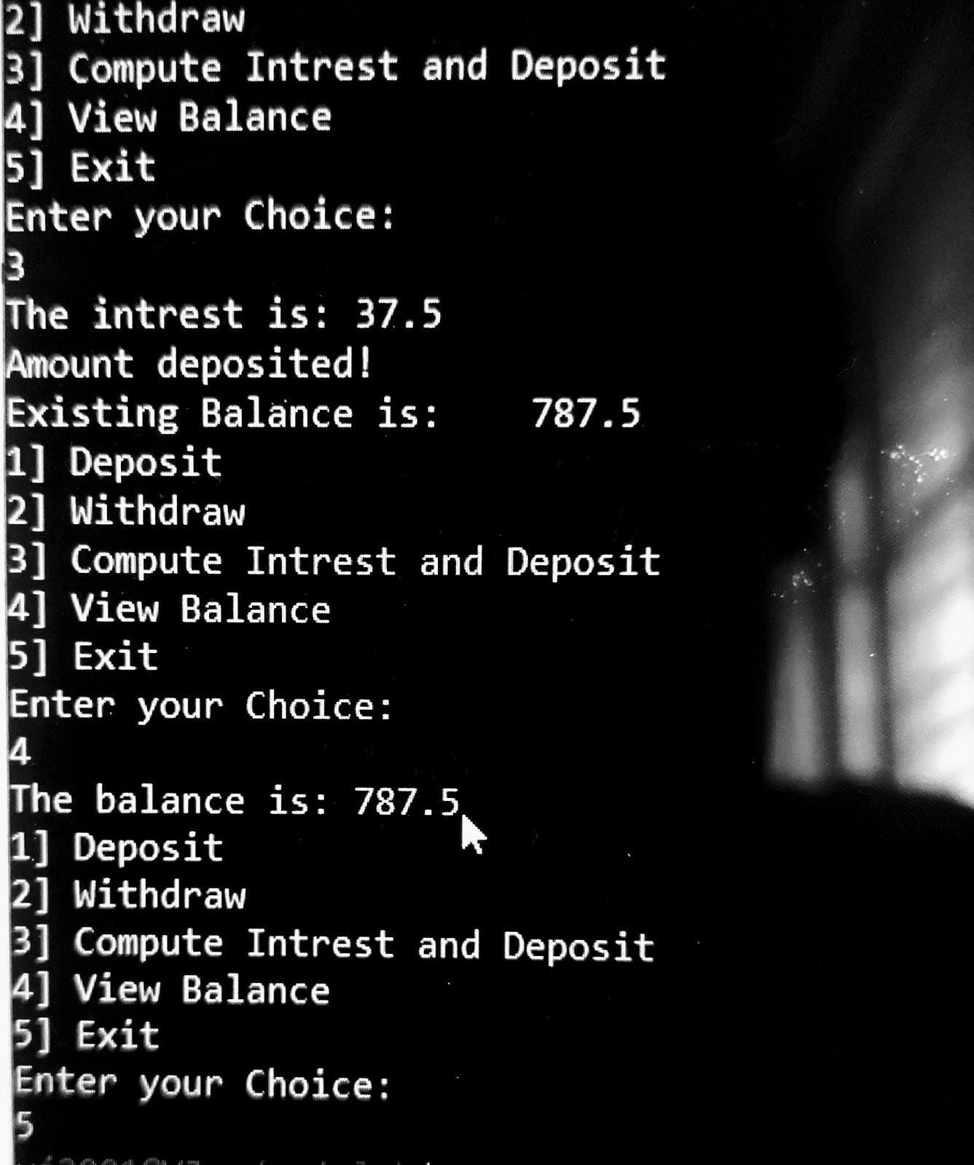

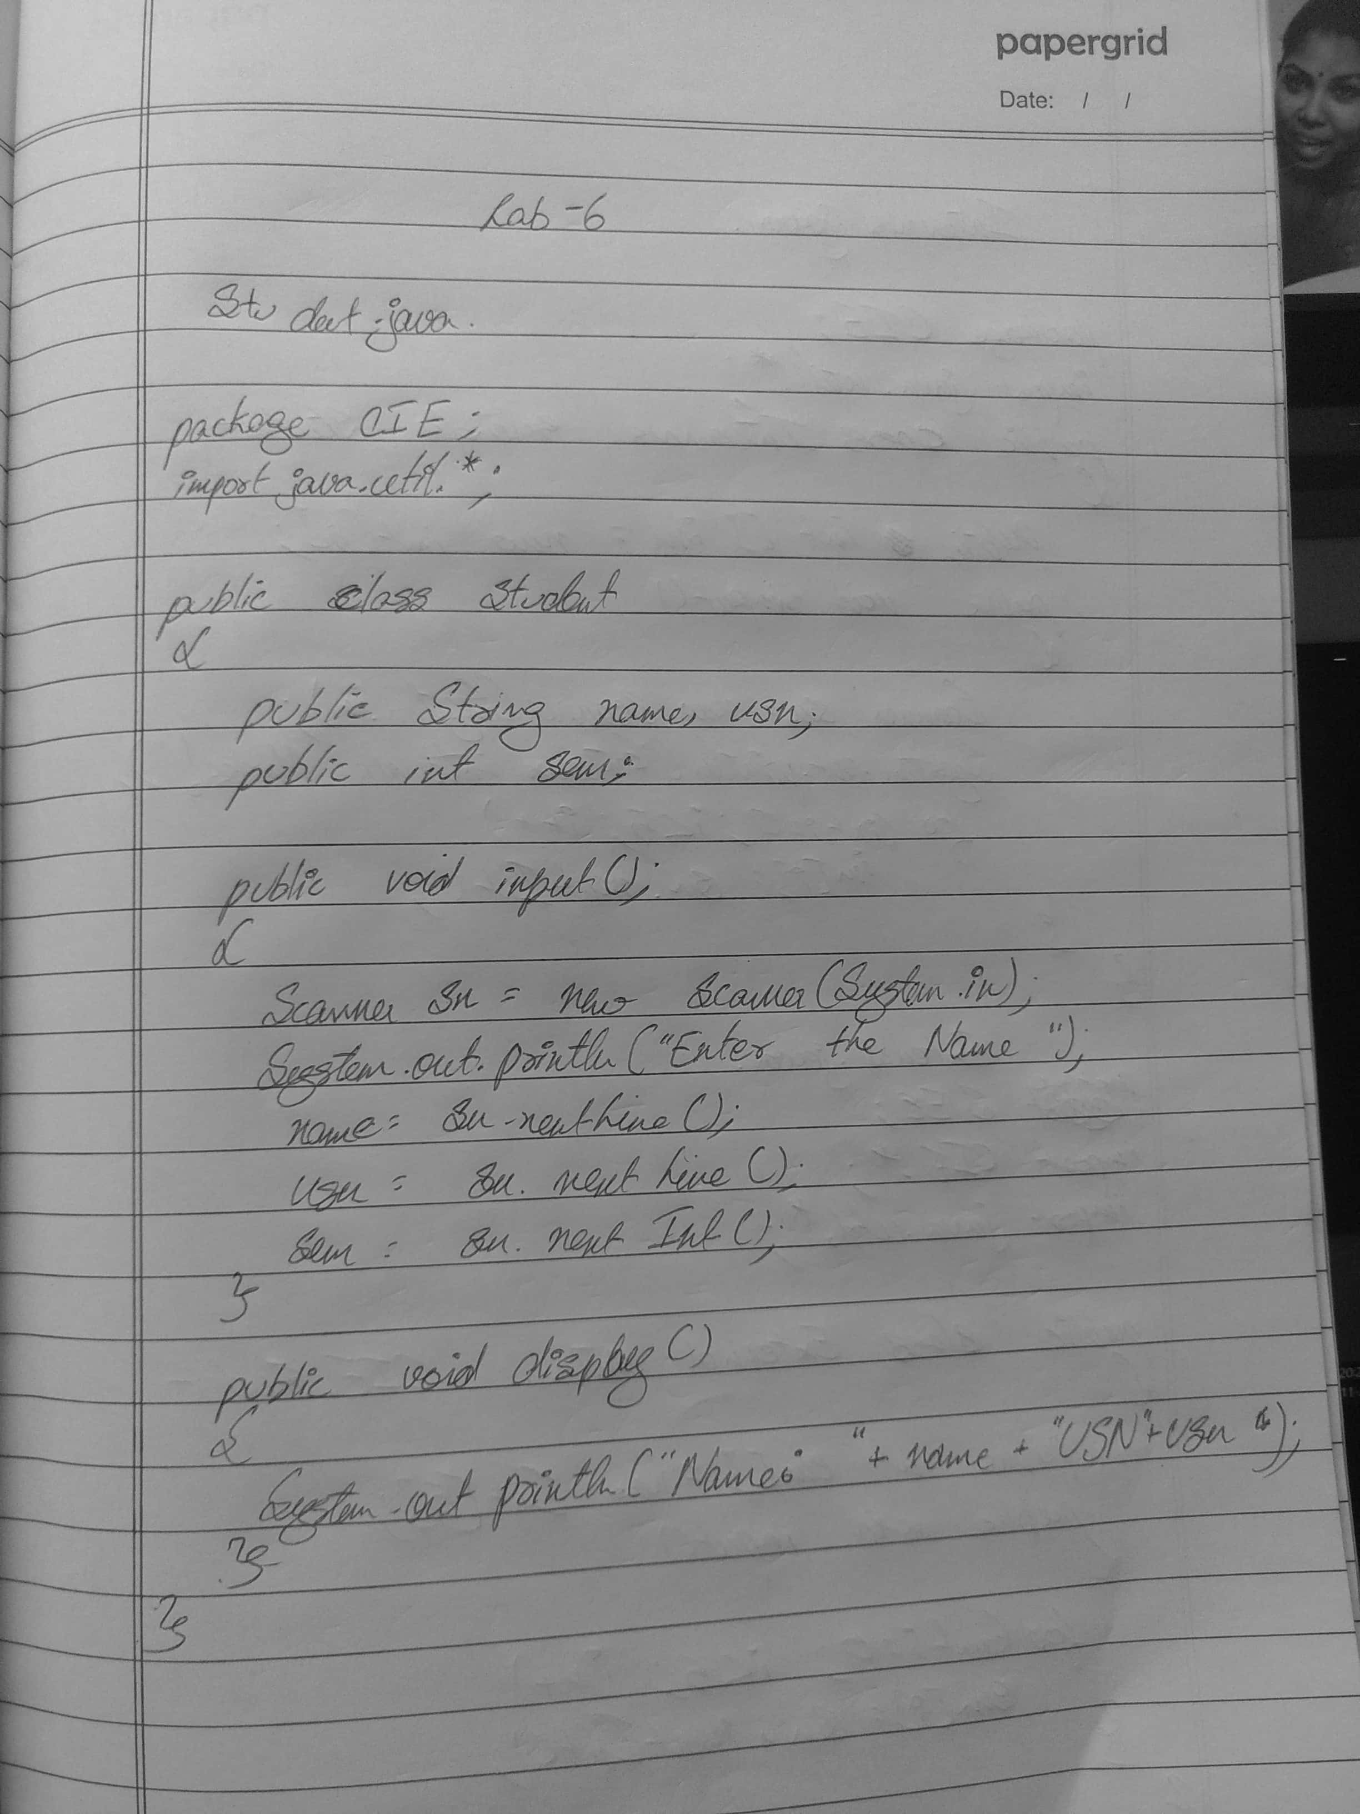



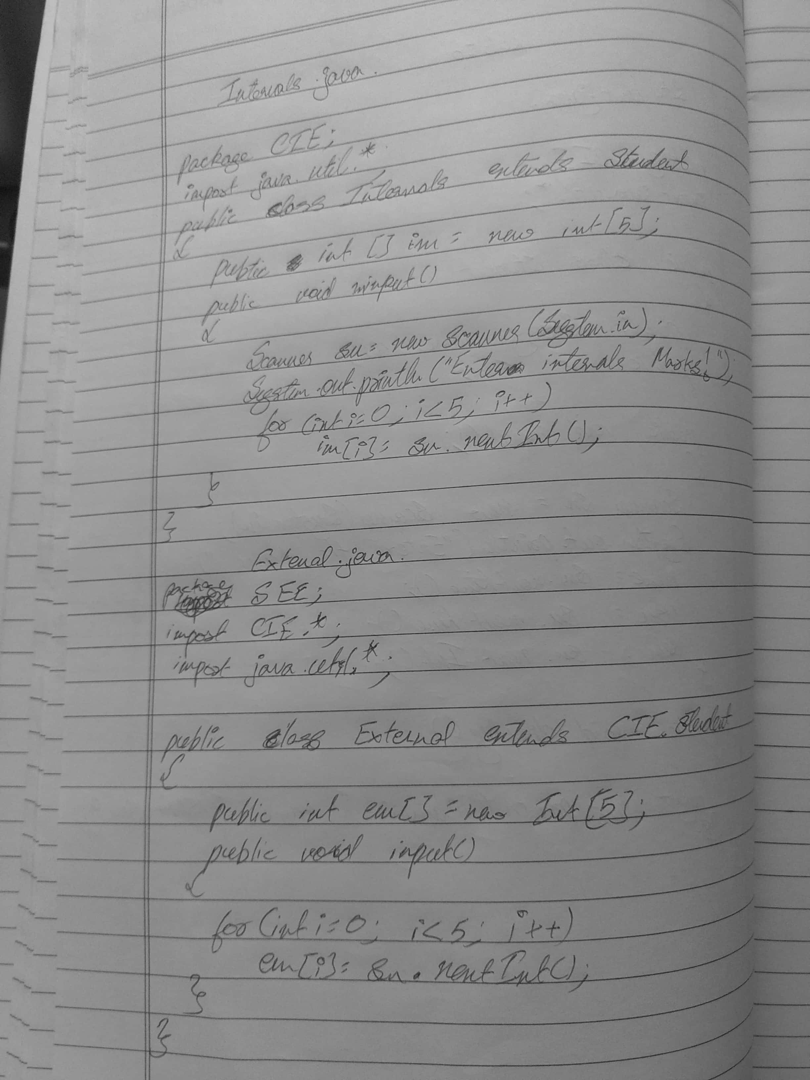



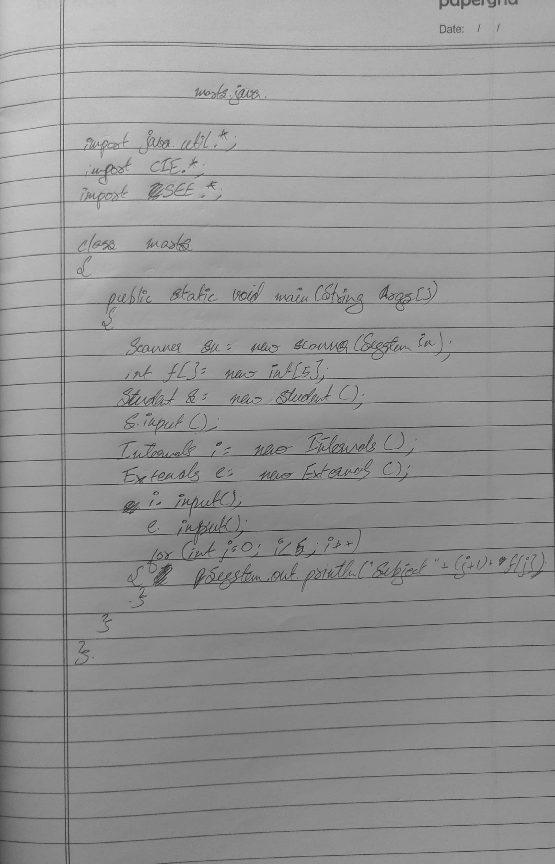



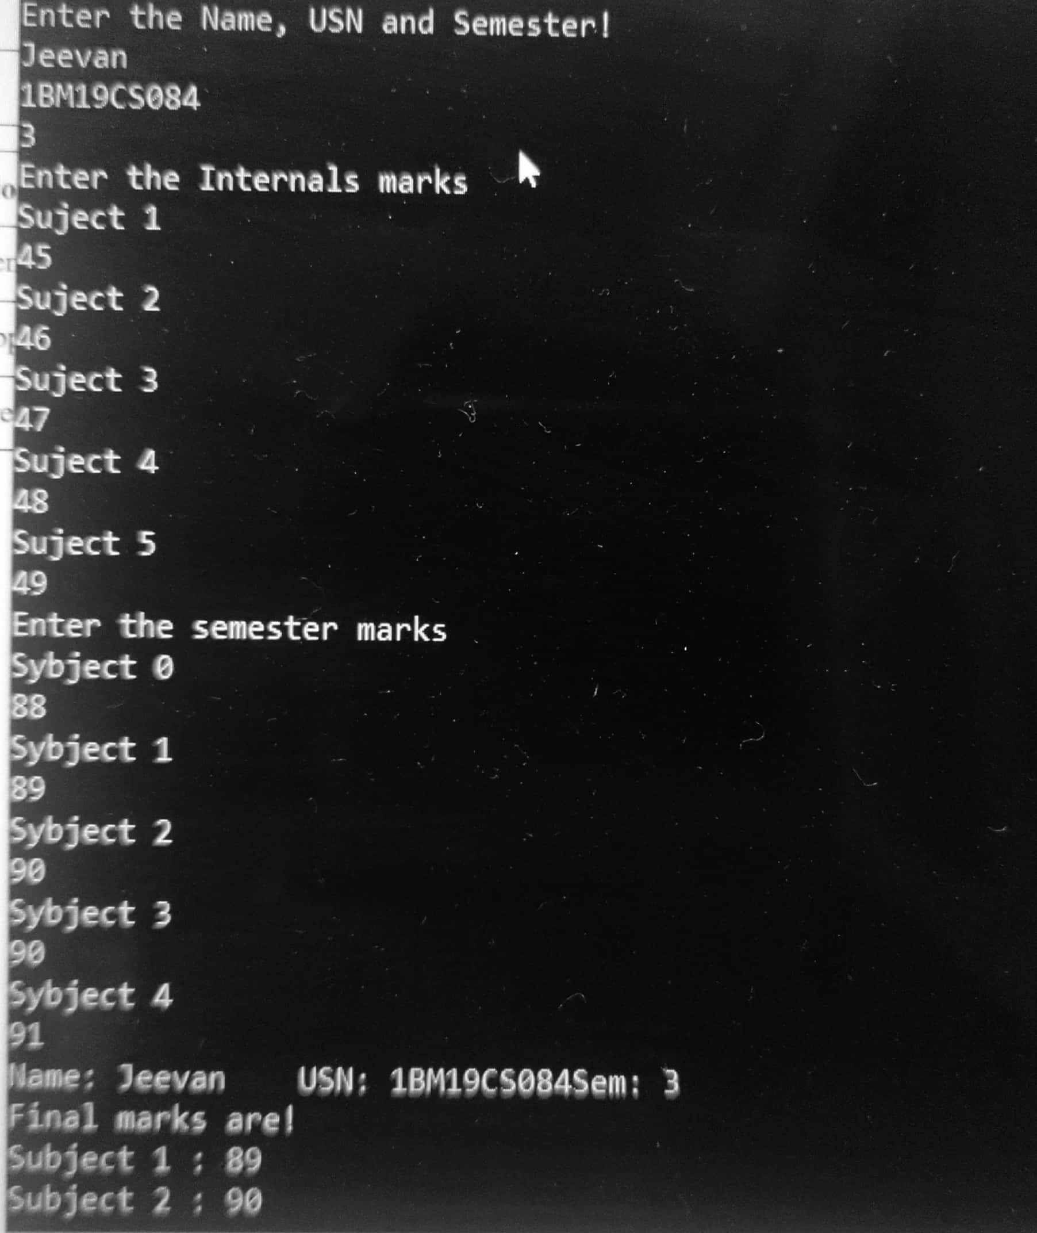



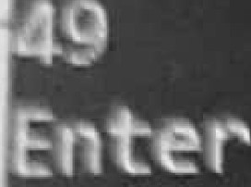

USN

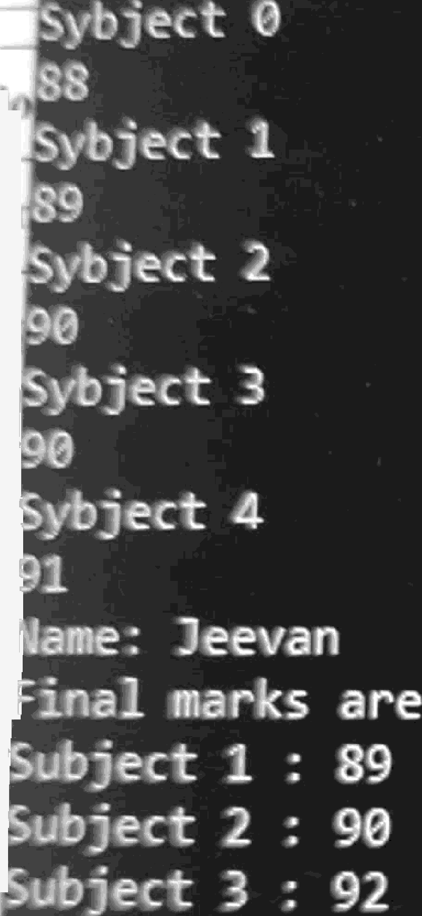

1BN19CS084Sen 3



4 93

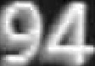



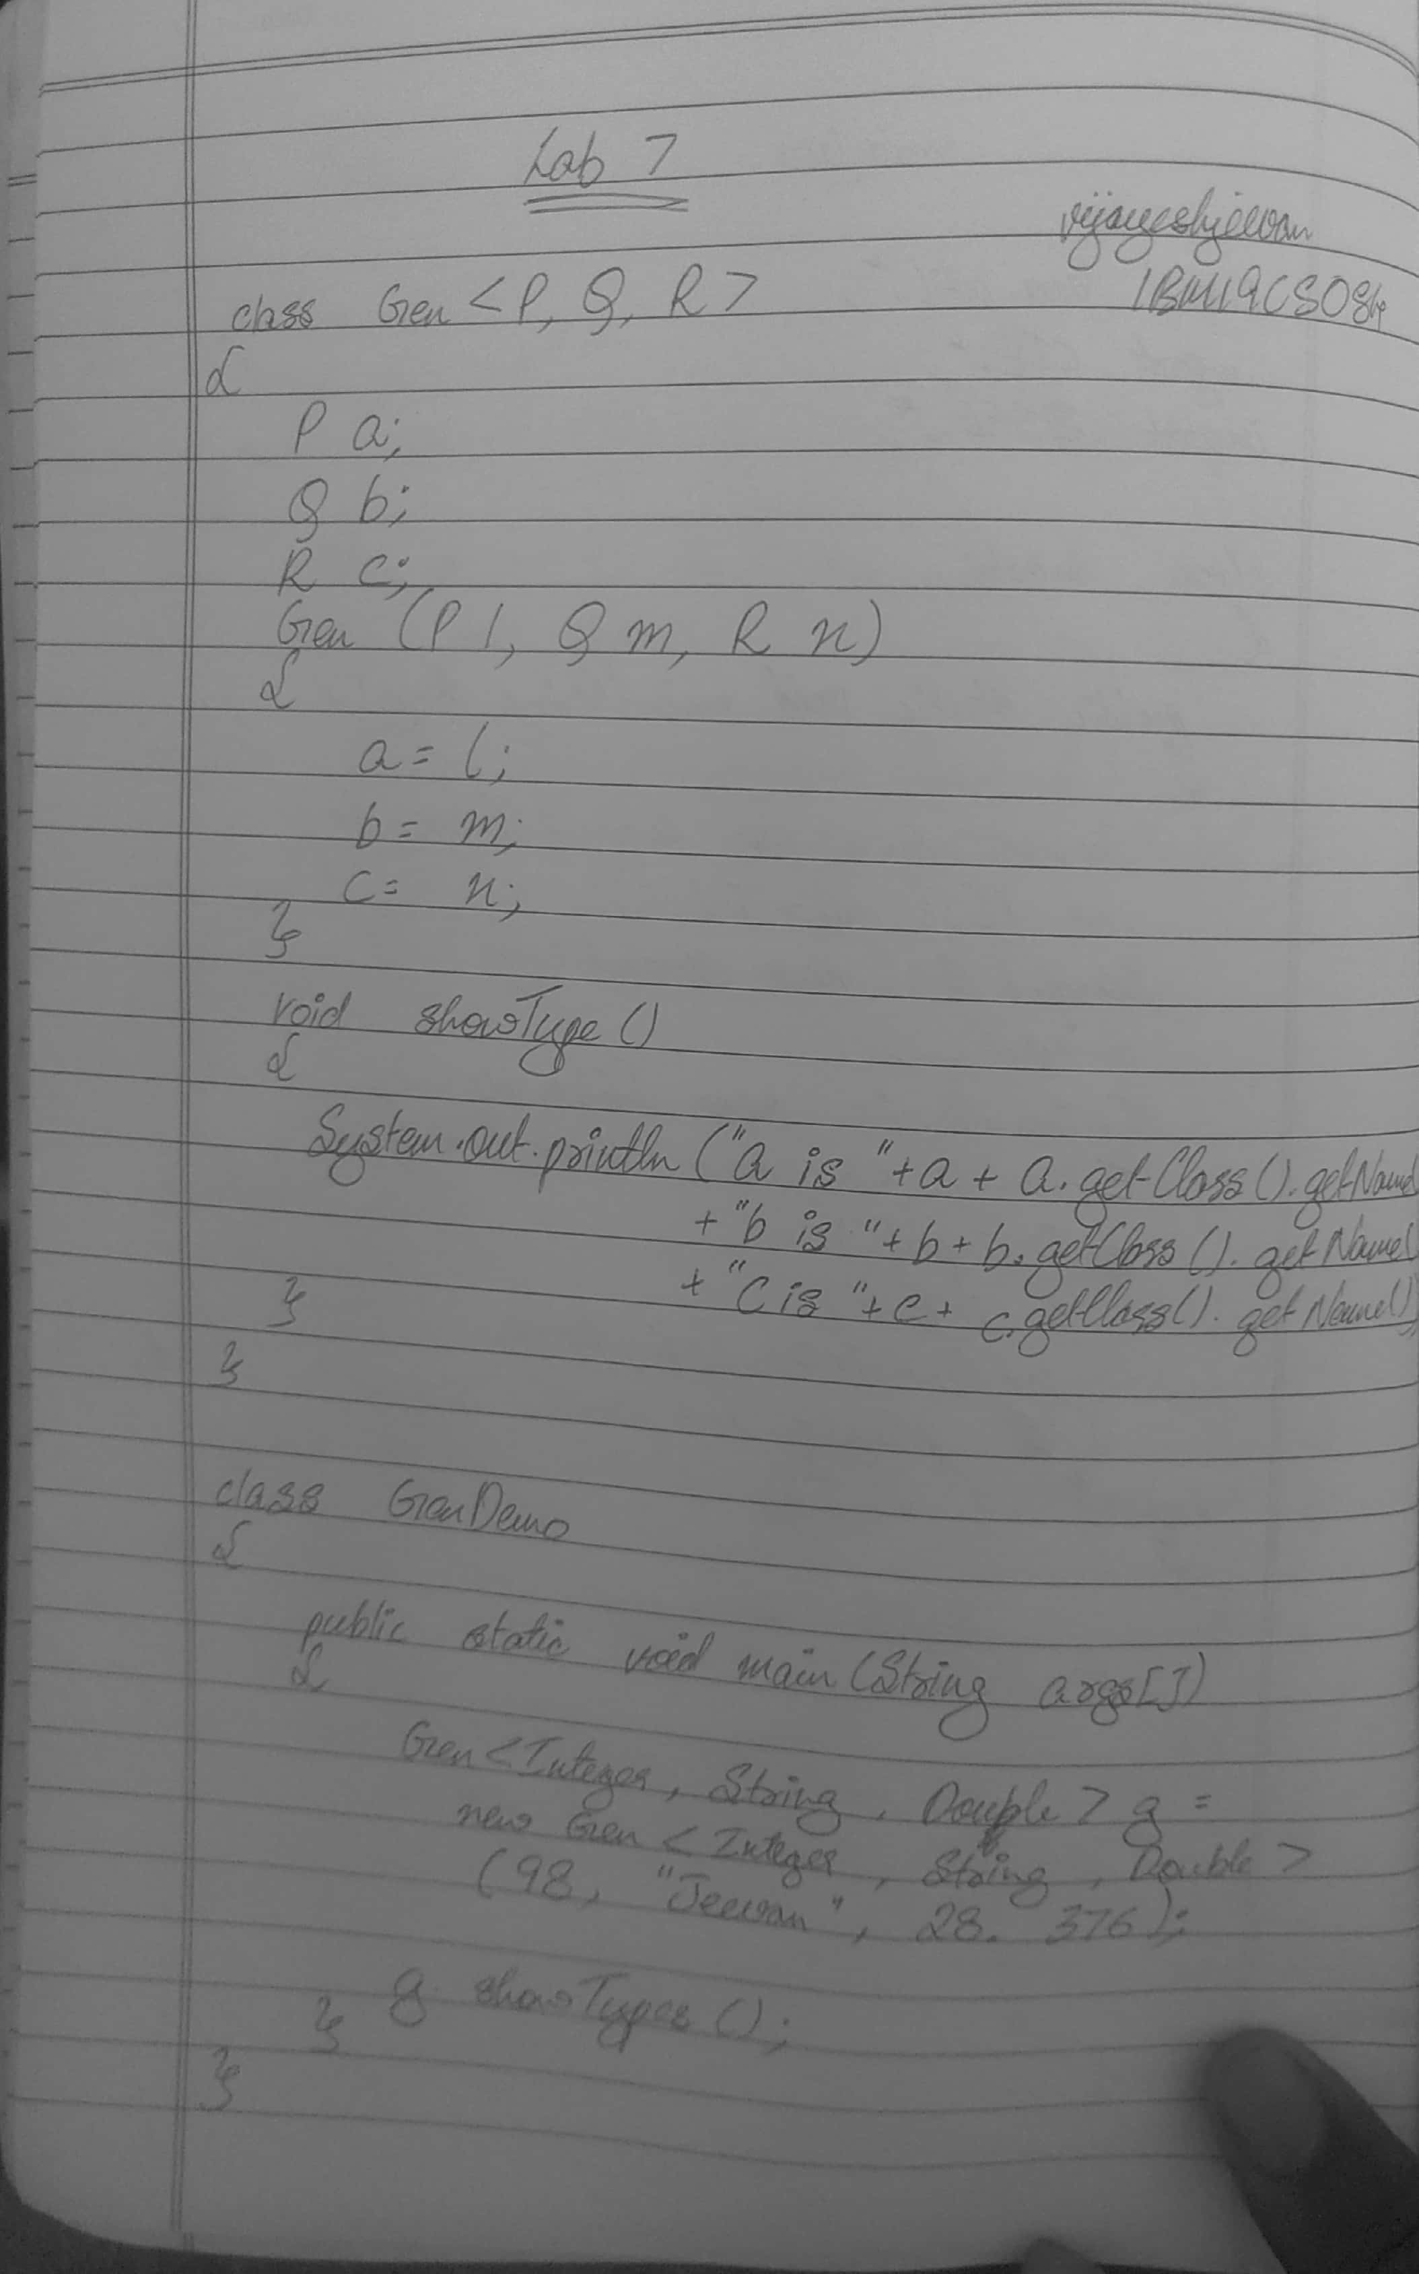



i ,.. ; , m»;! j y ¿, / „„ $ java GenDemo



= 98 Type: java.1ang. Integer

b = Jeevan Type: j ava. 1ang. String

: = 238.3598 Type: java. lang.Double

Scanned with CamScanner

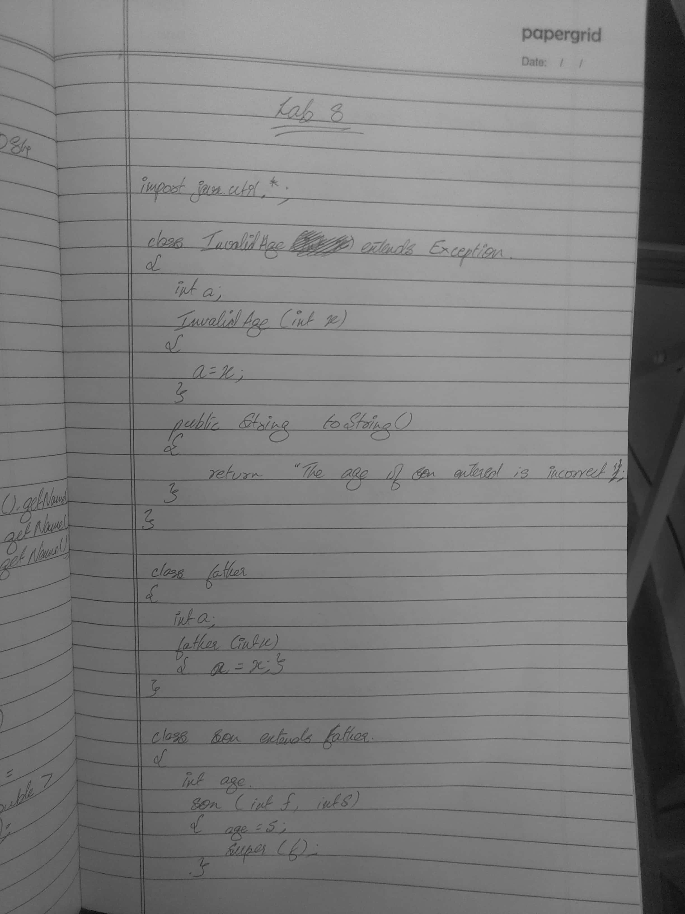



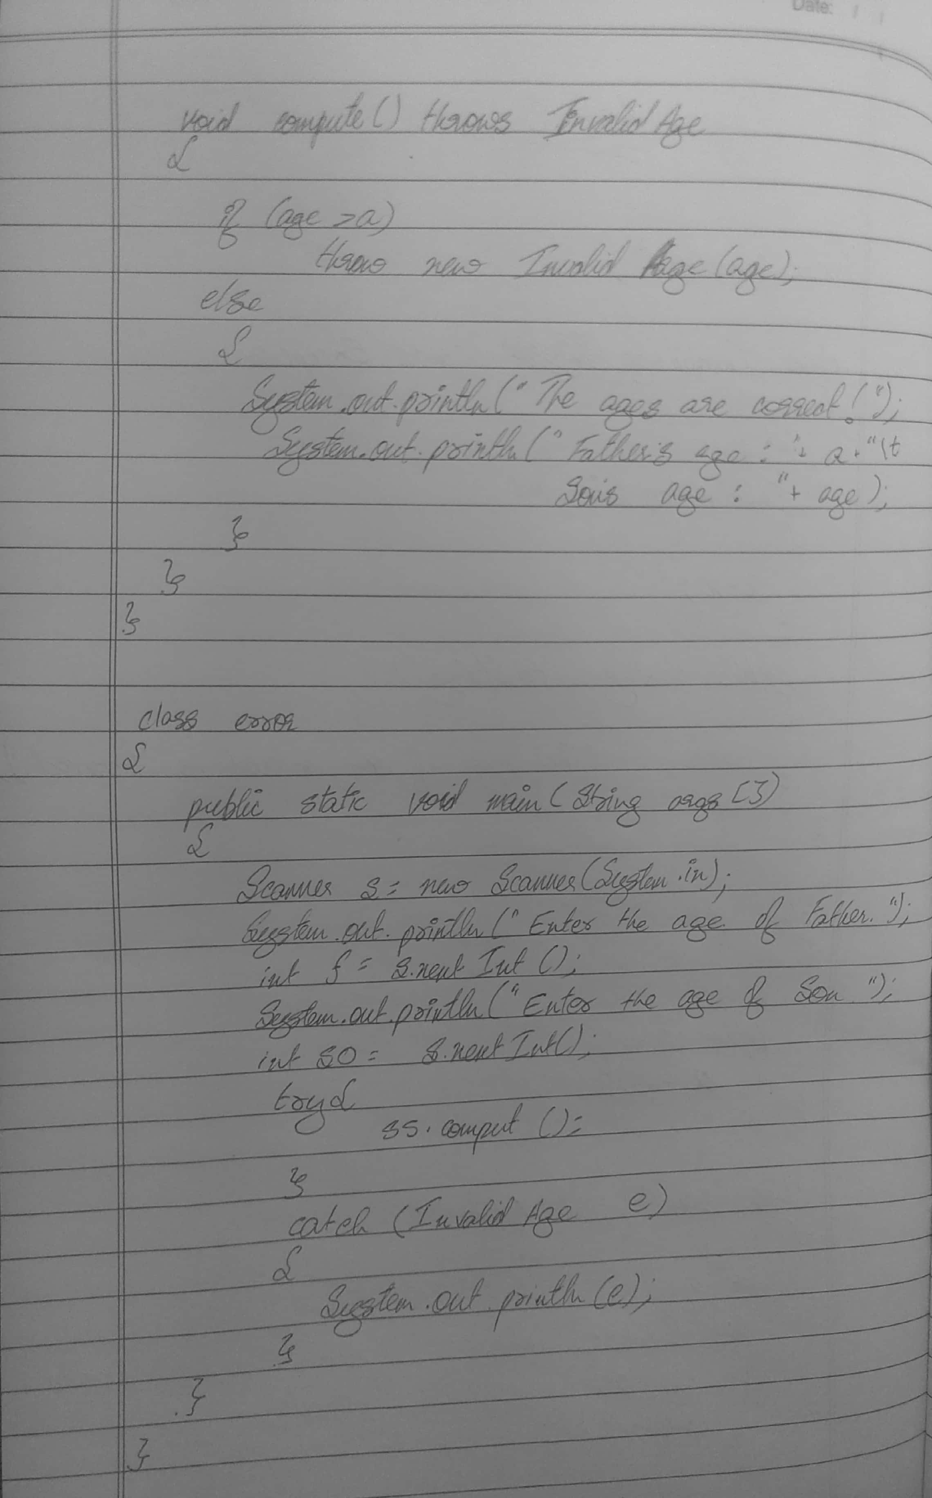



### *2001a.7 : /ooj - lab$ java error

r De age of the Father

## er tfie age of the Son

age of Son entered 45 is incorrect

#### @20Q1f«*V?:-/ooj-1ab$

java error

Beter the age 01 the

# Father

Errter the age of the Son 3S

### t¥he ages entered are correct I

Father’ s age=45 Son s age=35

Scanned with CamScanner

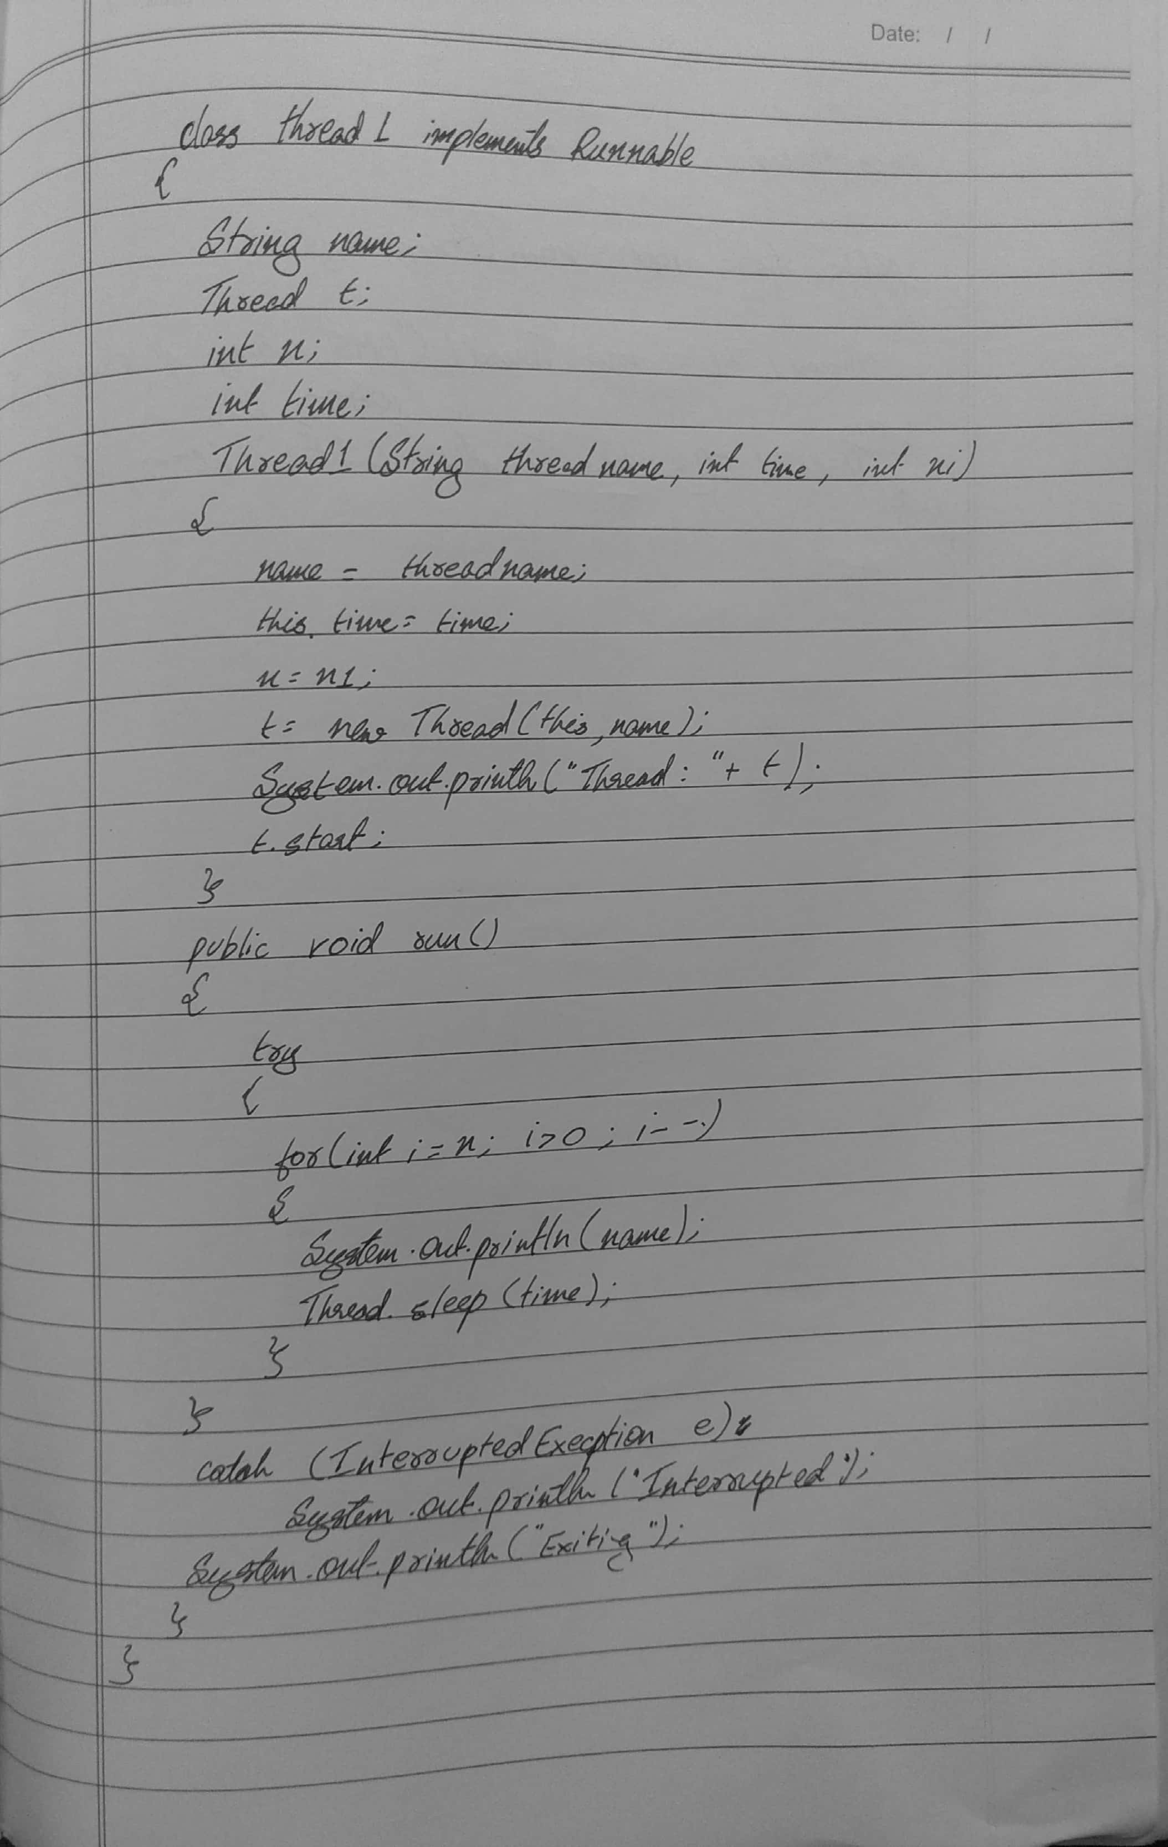



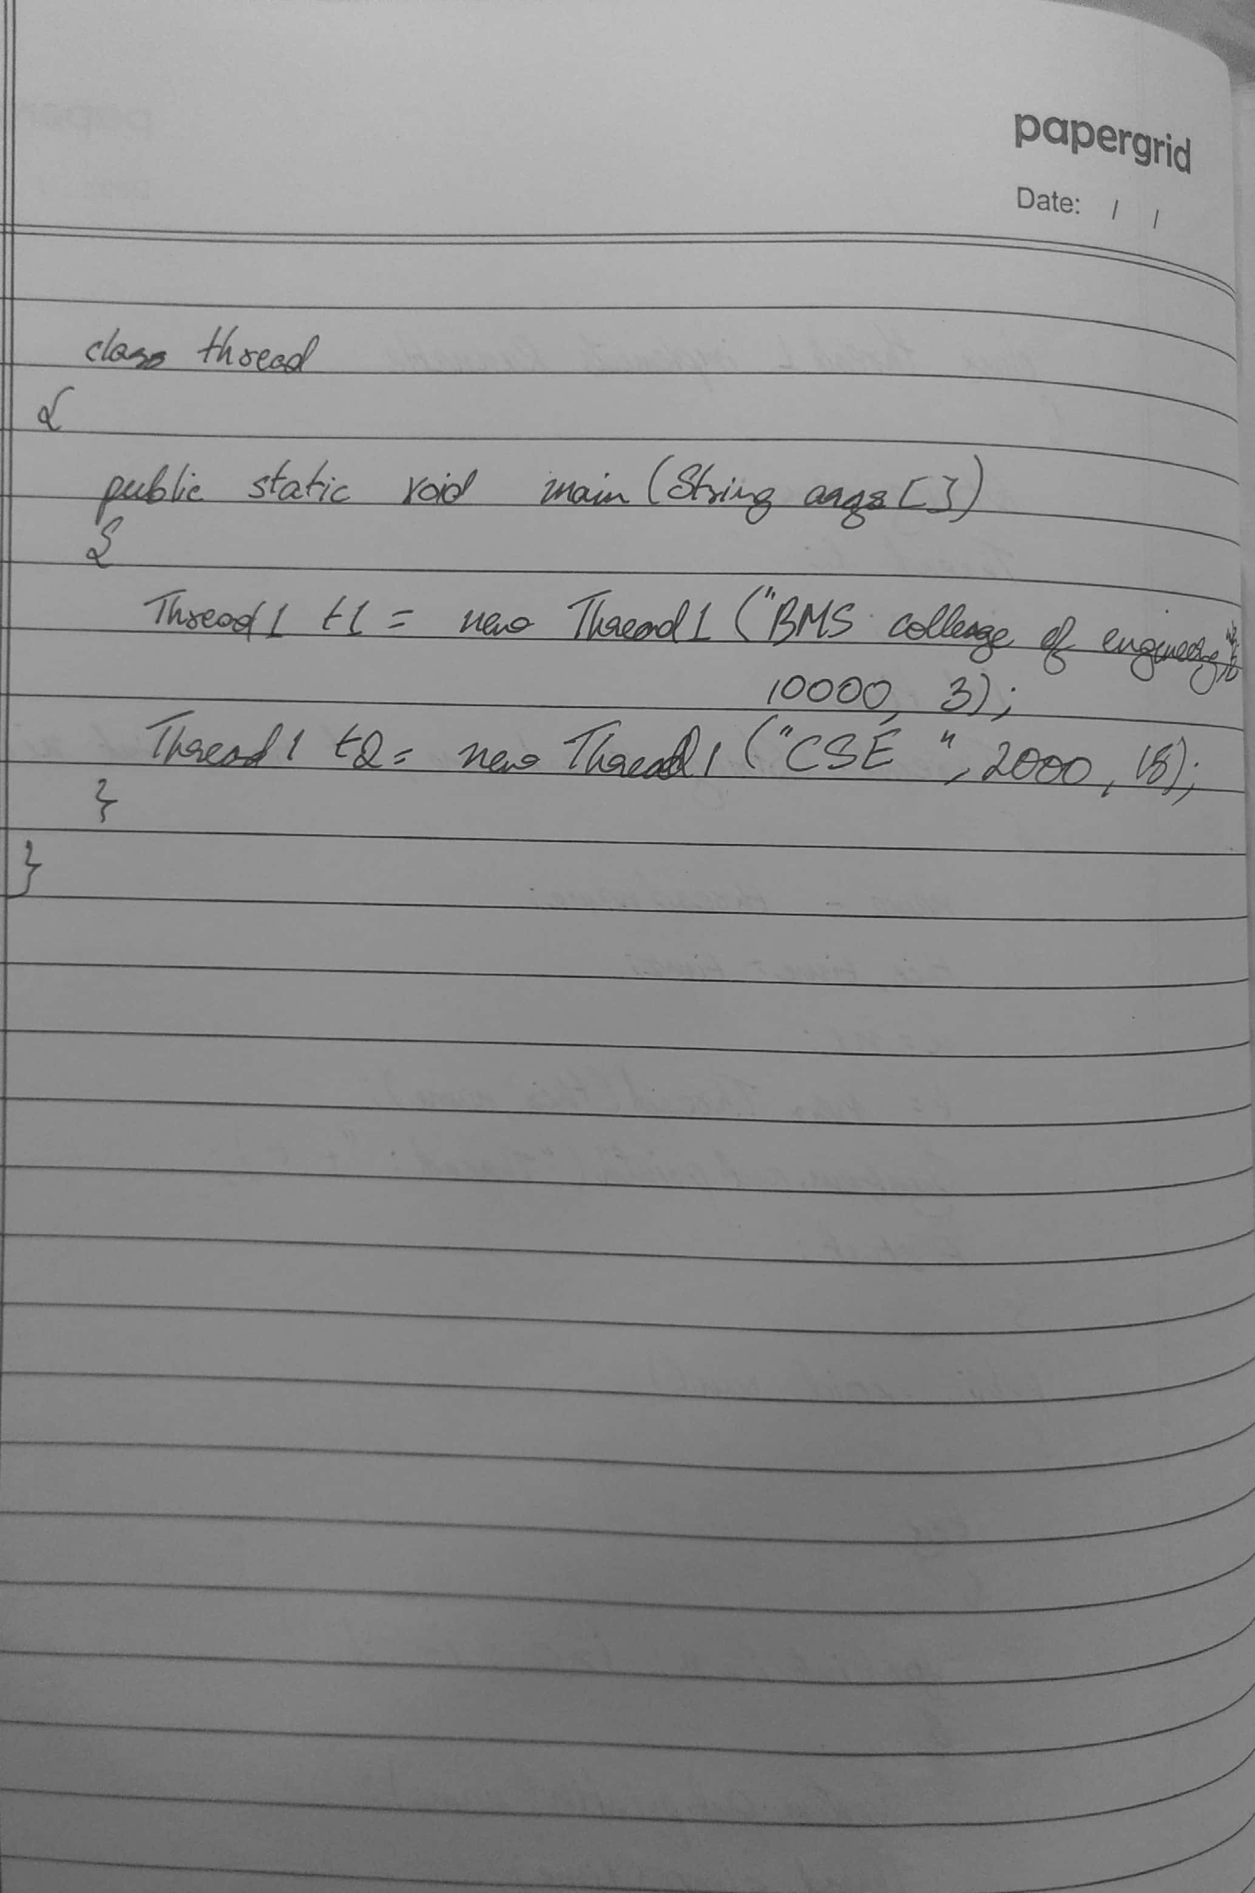



t hr«ad: Thr ced[BRs co11ege

##### thres { Thr eed[C$E, 5, meln]

Of en fl l '! fl 41, 5, na 1nJ

*!'** *<11e% of eng1neer1ngl

##### CSE

CSE

|  |  |  |  |  |
| --- | --- | --- | --- | --- |
| CSE  I¥Q | college | of | eng1neeringl | |
| CSE |  |  |  | |
| IPQ  CSE CSE CSE | co11ege | of | eng1neer1ng! | |
| CSE  BN5  CSE | co11ege  exitinjg. | of | eng1neer1ng I | ex1t1ng. |

Scanned with CamScanner

